**CSC 417 Unit 1 Day 3 Outline**

1. Advanced Computer Games
   1. Chess redux
      1. Why chess?
         1. Well-formalized knowledge domain
         2. Thought to challenge high-level intellectual capacity
         3. Detailed knowledge available
         4. Numeric scale to measure relative performance
      2. Search trees
         1. Typically minimax w/alpha-beta pruning
         2. In order to search, all possible moves must be represented
            1. There are 10120 possible games and an estimated 1043 “reasonable” games
      3. Methods for computer chess
         1. Shannon Type B
            1. Extend search depth beyond specified limit for “interesting” moves (captures, checks, exchanges, etc.)
            2. Moves with have significant impact on the state of the game require careful consideration
            3. Similar to how humans employ “progressive deepening” (anticipate likely moves and consider follow-up moves)
         2. Board/Move Representation
            1. Humans visually observe pieces on board
            2. 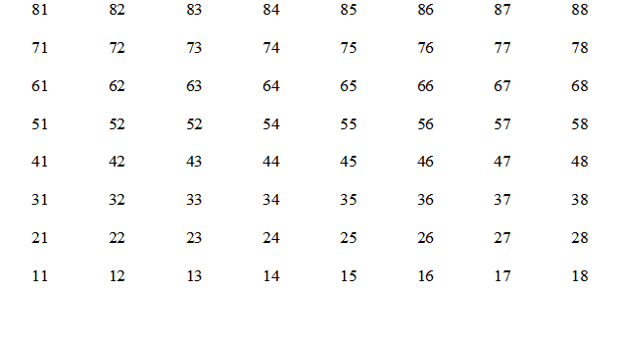Computers require a precise (mathematic) representation – such as  
               numeric values to represent squares
            3. Facilitates “pseudo-legal move lists” – calculation of possible moves
         3. Openings/Position Evaluation
            1. Openings are difficult, as there are many “general” rules (e.g. don’t move out queen too early) but also many exceptions to the rules
            2. Computers typically “brute force” openings and endgames (apply search to large databases containing many possibilities)
            3. Midgames are typically based on heuristic evaluation
      4. Heuristics for position evaluation

General guidelines for determining how “good” a move is

* + - 1. Development
         1. Move knights and bishops off back row to allow castling
      2. Center Control
         1. From the center, it is easier to move/threaten opponent’s pieces in any direction
      3. King safety
         1. Maintain strong defensive pawn structure in front of king
         2. Castling is generally recommend to protect king
      4. Material balance
         1. Number/strength of pieces relative to opponent
         2. Keep key pieces on the board
      5. Mobility/connectivity
         1. How many square can each piece move to/threaten?
    1. Humans vs. AI
       1. Humans are built for heuristics
          1. It is generally *not good* for people to repeatedly follow algorithms (get bored, make “silly mistakes”)
       2. AI must use numbers to represent heuristics, but humans aren’t always thinking in terms of *math*
       3. A strong AI chess system would play with *minimal* calculations (as humans do)
       4. AI systems can beat humans at chess, but must perform *many more calculations* to do so
       5. AI demonstrates *performance* (it plays well and often wins), but lacks *competence* (it doesn’t understand what it’s doing)
  1. Poker
     1. Why poker?
        1. Game of imperfect information
           1. Players do not see cards held by opponents
        2. Combines skill (knowledge of appropriate actions) and luck (distribution of cards)
        3. AI must emulate human elements of play
     2. Cepheus
        1. AI system that plays heads-up limit Texas hold’em (1013 decision points)
        2. Decision space is small enough to essentially compute all possible outcomes
        3. Learned based on rules of the game without human strategy analysis
     3. Libratus
        1. AI system that plays heads-up no-limit Texas hold’em (many more decision points)
        2. Extremely high hand win rate (did not “get lucky” or win a few big hands)
        3. General approach
           1. Pre-compute solution to an abstraction of the game

e.g. combine similar hands and bet amounts to reduce number of decision points)

* + - * 1. Subgame solving

If opponent makes unexpected moves not in the system’s current abstraction, re-calculate outcomes)

* + - * 1. Self-improvement

Add actions taken by opponent to abstractions and solve them